Raymond Delgado

Lab 10

April 22, 2020

Data Bricks Community:

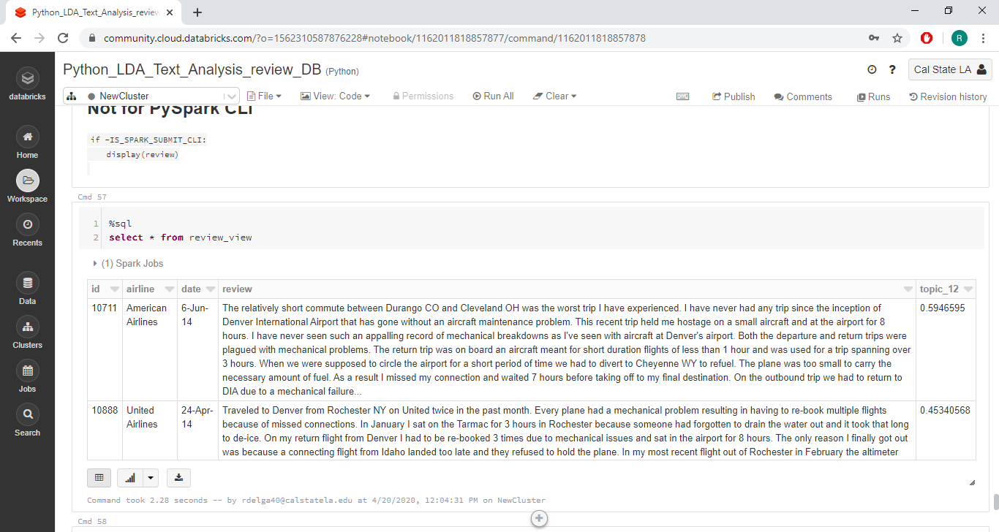

Spark-Submit Pyspark CLI:

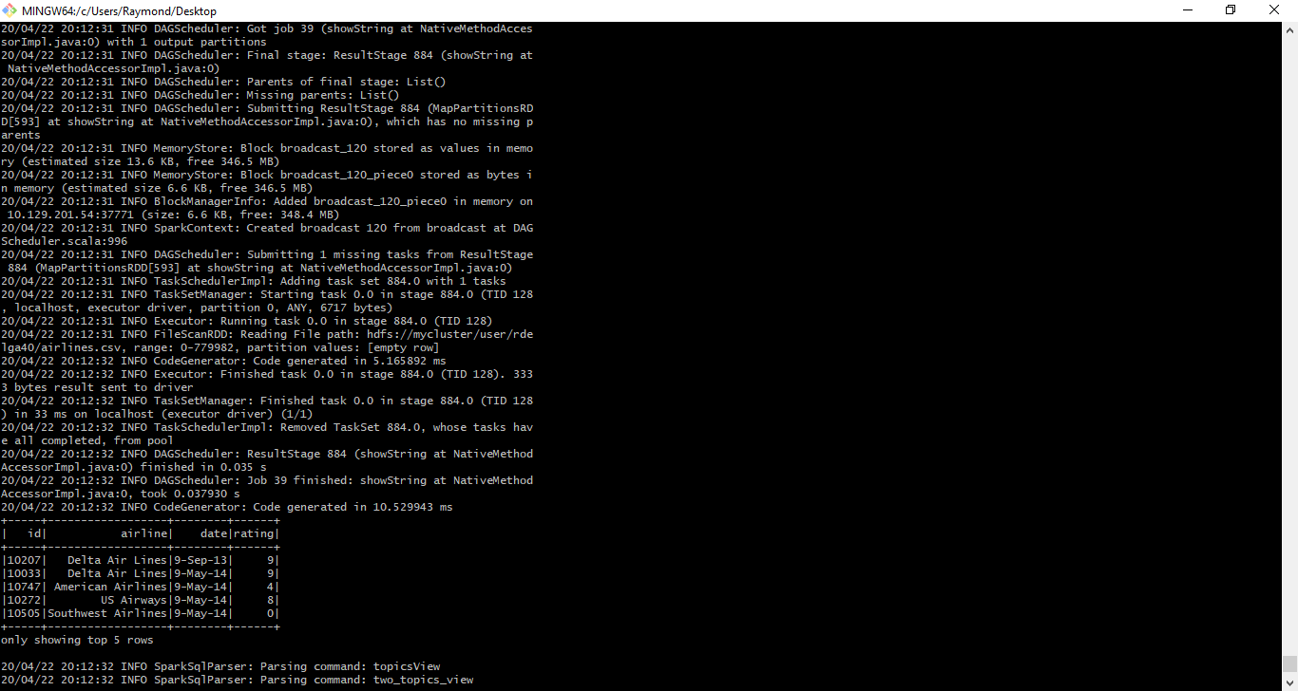

twoTopics.csv

